**TASK NO 02: Create a PowerPoint presentation with title “dives visualization” and add features.**

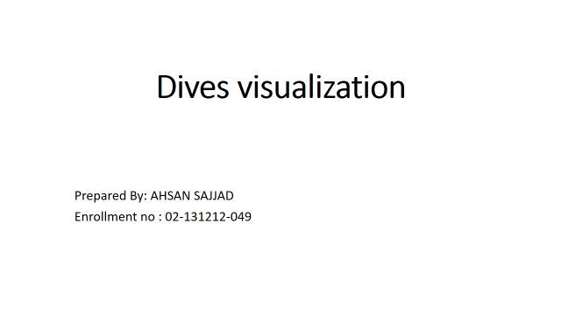**SOLUTION:**